Latest Round-ups:
Season 2019/20
#30
Midweek Action: In the Les Phillips Cup on Tuesday evening, Hallen required a penalty shootout to knock out First Division visitors Cheddar in their quarter final clash. It was a fast start to the game, with Sacha Tong putting the hosts ahead in the 14th minute, before Steve Holland responded for the Cheesemen a couple of minutes later. Hallen created a number of opportunities during the second half, but they were unable to break down the Cheddar back-five, meaning the game would be decided on spot kicks. With the shootout locked at 3-3 following four attempts apiece, Cheddar blazed an effort over the bar, leaving Aron Robbins to knock home the winning penalty for Ray Johnston’s side. The following evening, Premier Division leaders Bradford Town came from behind to beat Roman Glass St George 2-1 to reach the final four of the competition. It was the home side who led at the interval after Steve Fitzpatrick fired them ahead in the lead up to half-time. The Bobcats got back on level terms early in the second half through Lewis Powell, setting up the possibility of another tie to be decided from 12 yards. Bradford didn’t allow that to happen however, and following a smart ball over the top of the defence by Jack Witcombe, Powell added the finishing touches five minutes from time to book the visitors passage through to the semi-finals.
Les Phillips Cup Semi-Final draw
Following Wednesday’s clash at Oaklands Park, the semi-final draw for the Les Phillips Cup was completed.
- Bridgwater Town vs Tavistock or Warminster Town
- Bradford Town vs Hallen

The only league fixture to beat the weather during the week took place at the Hand Stadium, where two goals in the final quarter saw Premier Division title challengers Plymouth Parkway capture a 2-0 win over Clevedon Town. Following 66 goalless minutes, Clevedon were handed an excellent opportunity to forge ahead, but visiting keeper Kyle Moore came out on top in the one-on-one to preserve his clean sheet. Before anyone had a chance to catch their breath, Parkway attacked down the other end, with the ball eventually finding its way to Jordan Bentley who fired the Devon side in front. An inspired substitution then wrapped up the three points, with Jack Calver scoring from his first touch, whipping home a 25-yard free kick 15 minutes from time to double Parkway’s advantage.

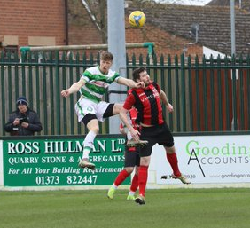
Premier Division: Following the postponement of Bradford Town’s fixture on Saturday afternoon, Plymouth Parkway have taken ownership of top spot following a comprehensive 5-0 victory away at Cadbury Heath. The away side got off to an electric start at Springfield, going ahead after just three minutes when top scorer Adam Carter poked home. An own-goal doubled Parkway’s tally at the end of the first half, before goals from Craig Duff and Mikey Williams within 15 minutes of the restart put the game to bed. Considering how tight things are atop the division, goal difference may yet be crucial come the end of the season, so Duff’s second goal in stoppage time to make it 5-0 was a perfect finish for the Devon side. Another team to win by five goals to nil on their travels were Bitton, with debutant Liam Bishop making an instant impact in their fixture at Bridport. After skipper Scott Brice whipped home an excellent free-kick to break the deadlock in the 28th minute, Bishop struck in first half stoppage time to give Bitton a two-goal lead at the interval. Matt Groves then played a starring role for the away side in the early stages of the second half, providing assists for both Jordan Whittaker and then Bishop as Bitton took control of the game. The final goal came on the hour mark and it was that man Bishop once more, with his first game for his new club ending with him taking home the match-ball following a fine treble. Westbury United produced a thrilling comeback during the final quarter-hour of their home clash with Brislington, scoring three times in the final 13 minutes to win 3-2. 70 goalless minutes had passed at Meadow Lane before Brislington went ahead, with Lewis Ellington’s cross finding Reeko Best who applied the finishing touches. No sooner had they taken the lead, Brislington were celebrating once more, with Best turning provider for George Box who doubled their advantage. Westbury needed to regroup quickly, and they did just that, with frontman Callum Demkiv flicking the ball home to give them a foothold in the contest. Demkiv’s impact on the game continued to grow, and after pulling his side to within a goal, his low drive into the visitors box deflected off a Brislington defender and nestled in the bottom corner to restore parity. With four goals in the space of nine minutes, there was always likely to be late drama, and it came in stoppage time, with a corner from Ryan Bole finding the head of Sam Jordan who flicked home the fifth and final goal of the contest to the delight of the home fans. Exmouth Town moved up into third spot after claiming a 2-0 victory at home to Wellington. In a match which proved to be tougher than it looked on paper, Exmouth were only assured of securing all three points in stoppage time, when Ben Steer added to Jamie Dirrane’s goal earlier in the contest, with the away side seeing a potential equaliser ruled out midway through the second half for a foul on the keeper.
Action from Westbury’s 3-2 victory over Brislington, courtesy of Martin Pearce.

Fourth-placed Hallen struck twice in the final 20 minutes at Fairfax Park to grab a 2-2 draw away at Bridgwater Town. Having already had a goal disallowed inside the opening ten minutes, Bridgwater made their fast start count in the 22nd minute, when a long throw from Tom Ellis found its way to Jake Brown who fired home a thunderous volley. Less than five minutes later, Town found themselves two goals to the good, with another throw into the box from Ellis headed into the Hallen goal by Owen Irish. The visitor’s had an eight-game unbeaten league run to preserve, and they turned the tables on Bridgwater, utilising a long throw of their own to half the deficit 20 minutes from time with Sacha Tong finishing smartly from inside the area. Then, with time running out, Hallen grabbed what could be a crucial point, with Aron Robbins poking the ball home with what proved to be the final kick of the game. Odd Down remain in bottom spot after relinquishing an early lead during their 2-1 loss at home to Buckland Athletic. The Bath outfit have been on a horror run of form, and after Charlie Wiles-Richards had headed them in front, they were unable to keep their opponents at bay, with Lloyd Gardner equalising not long after the opener. Both sides were then reduced to ten men following a pair of straight red card’s, and it was Buckland who reacted best, taking all three points home with them when Gardner struck once more in the closing stages. Cribbs ended an eight-match losing run by holding Shepton Mallet to a goalless draw at the Lawns, while Roman Glass St George are up to 14th following an excellent 3-0 victory at home to Street.
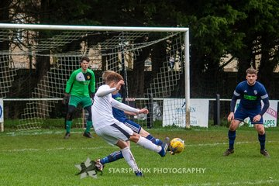
First Division: The top sides in the First Division all enjoyed success on Saturday afternoon, as the unpredictable title race heads towards a thrilling finish. As many as six sides will feel they are capable of claiming top spot, and of those six, all four whose game’s beat the weather managed to add three more points to their tally. Leading the way continues to be Calne Town, and they relied on a stoppage time winner to beat Wincanton Town 2-1 at Bremhill View. Leading scorer Stuart Windsor recently reached three figures for the Lilywhites, and he was crucial once more against Wincanton, powering his side into a one goal lead midway through the first half. The away side currently reside in the top half, and they proved a tough out for Calne, grabbing an equaliser on the hour mark through Gary Chapman. With Calne looking set to drop two crucial points, Windsor popped up with a vital 92nd minute winner, tucking the ball home from a cross by second-half substitute Lewis McCarron.
Calne Town have an effort on goal during their hard-fought 2-1 win at Bremhill View over Wincanton Town.
Image courtesy of Starsphix_Pics.

Wells City were another title challenger who were forced to battle for their latest victory, edging past Lebeq United by one goal to nil at the Athletic Ground. The crucial goal came after just eight minutes, with star man Harry Foster slotting the ball home to extend his lead atop the division’s goalscoring charts. Foster will gain many of the plaudits, but it was keeper Harvey Wilkinson who was Wells’ standout performer against Lebeq, saving a 37th minute penalty to keep the visitors at bay, before then producing a couple of excellent stops in the closing stages to preserve City’s clean sheet. Things proved much easier for Longwell Green Sports, who saw different goalscorers fire them to victory at home to Bishop Sutton. The hosts scored twice in either half, with Aidan Sanfelice and Luke Bryan making it 2-0 at the break, before Sam Crumb and debutant Paul Uppington added the finishing touches to a comfortable home win. The fourth promotion hopeful to triumph on Saturday were Ashton & Backwell United, with two first half goals leading them to a 2-0 win over Cheddar. The Stags have now won nine of their last ten league fixtures since the start of December to put themselves firmly in the title race, with goals at the beginning and end of the first half helping them see off Cheddar at the Lancer Scott Stadium. Portishead Town jumped up a couple of spots in the bottom half after sneaking to a 1-0 win away at Devizes Town in the day’s early kickoff.

Western League Leading Scorers
*All goalscoring stats via Full-Time FA website
PREMIER DIVISION LEADING GOAL SCORERS (League only):
Adam Carter (Plymouth Parkway) – 28
Jordan Harris (Exmouth Town) – 22
Jack Fillingham (Shepton Mallet) – 20
Leighton Thomas (Street) – 18
Mikey Williams (Plymouth Parkway) – 17
Jack Taylor (Bridgwater Town) – 16
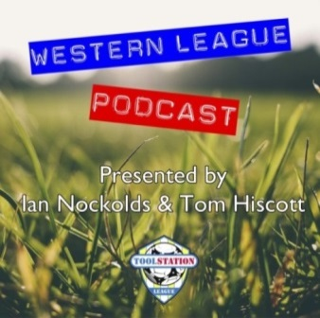
FIRST DIVISION LEADING GOAL SCORERS (League only):
Harry Foster (Wells City) – 24
James Rustell (Radstock Town) – 19
Stuart Windsor (Calne Town) – 19
Alex Murphy (Sherborne Town) – 14
Josh Bright (Corsham Town) – 13
Toby Cole (Wincanton Town) – 12

LEADING SCORERS IN ALL COMPETITIONS:
Jack Crago (Tavistock) - 35
Be sure to check out the latest podcast, where Ian, Tom & guests recap all the latest news and results from around the Western League. To follow along all season, each broadcast will be available at the following link: http://www.toolstationleague.com/podcasts.php
Harry Foster (Wells City) – 31
Adam Carter (Plymouth Parkway) – 28
Jack Fillingham (Shepton Mallet) – 25
Jordan Harris (Exmouth Town) - 25
James Rustell (Radstock Town) – 24
Jack Taylor (Bridgwater Town) – 23

Latest Results
Tuesday 18th February 2020
Les Phillips Cup – Quarter Final
Hallen 1-1 (4-3 pens) Cheddar 55
Wednesday 19th February 2020
Premier Division
Clevedon Town 0-2 Plymouth Parkway 130
Les Phillips Cup – Quarter Final
Roman Glass St George 1-2 Bradford Town 85
Saturday 22nd February 2020
Premier Division
Bridgwater Town 2-2 Hallen
Bridport 0-5 Bitton 93
Cadbury Heath 0-5 Plymouth Parkway 82
Cribbs 0-0 Shepton Mallet 71
Exmouth Town 2-0 Wellington 251
Odd Down 1-2 Buckland Athletic
Roman Glass St George 3-0 Street
Westbury United 3-2 Brislington 72
First Division
Ashton & Backwell United 2-0 Cheddar 78
Calne Town 2-1 Wincanton Town 94
Devizes Town 0-1 Portishead Town 44
Longwell Green Sports 4-0 Bishop Sutton 85
Wells City 1-0 Lebeq United 50

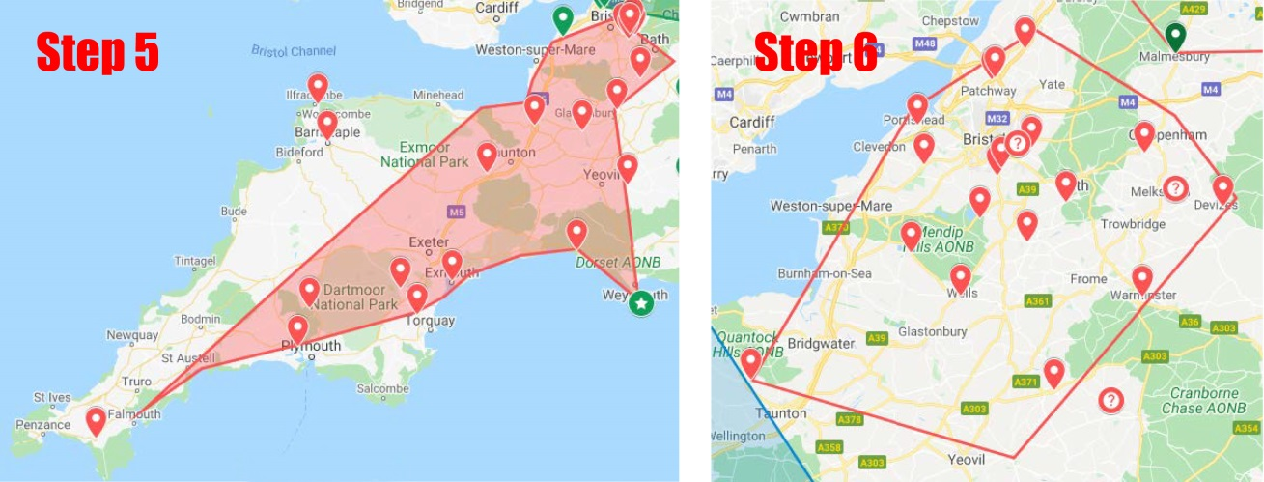
League Restructuring
The mapping exercise carried out below takes an early look at how the divisions may set up next season. These are based on how the tables looked at the end of 2019 and nothing is set in stone at this point in time. All information currently available can be found at the following link: http://www.toolstationleague.com/newsitem.php?selection=60

Upcoming Fixtures
Tuesday 25th February 2020
Premier Division
Bitton vs Clevedon Town 19:30KO
Chipping Sodbury Town vs Shepton Mallet 19:30KO
Hallen vs Buckland Athletic 19:30KO
Plymouth Parkway vs Bradford Town 19:30KO
First Division
Almondsbury vs Lebeq United 19:30KO
Bristol Telephones vs Longwell Green Sports 19:45KO
Portishead Town vs Sherborne Town 19:30KO
Wincanton Town vs Cheddar 19:30KO
Somerset FA Premier Cup – Quarter Final
Wells City vs Bridgwater Town 19:30KO
Wednesday 26th February 2020
Premier Division
Tavistock vs Roman Glass St George 19:30KO
Wellington vs Keynsham Town 19:30KO
First Division
Oldland Abbotonians vs Bishop Sutton 19:45KO
Warminster Town vs Devizes Town 19:45KO
Devon FA St Lukes Bowl – Quarter Final
Willand Rovers vs Exmouth Town 19:30KO
Friday 28th February 2020
First Division
Bishop Sutton vs Cheddar 19:30KO
Saturday 29th February 2020 (KICK OFF AT 3.00PM UNLESS NOTED)
FA Vase – Quarter Finals
Hebburn Town vs Plymouth Parkway
Wroxham vs Bitton
Premier Division
Bridgwater Town vs Chipping Sodbury Town
Buckland Athletic vs Shepton Mallet
Clevedon Town vs Exmouth Town
Cribbs vs Bridport
Hallen vs Bradford Town
Street vs Westbury United
Tavistock vs Cadbury Heath
Wellington vs Roman Glass St George
First Division
Almondsbury vs Devizes Town
Calne Town vs Longwell Green Sports
Corsham Town vs Ashton & Backwell United
Lebeq United vs Bristol Telephones 15:15KO
Oldland Abbotonians vs Sherborne Town
Portishead Town vs Welton Rovers
Radstock Town vs Hengrove Athletic
Warminster Town vs Bishops Lydeard
Wells City vs Wincanton Town
League Tables
Premier Division
 |  | P | W | D | L | F | A | GD | PTS
1 | Plymouth Parkway | 22 | 19 | 1 | 2 | 78 | 19 | 59 | 58
2 | Bradford Town | 22 | 19 | 1 | 2 | 69 | 20 | 49 | 58
3 | Exmouth Town | 23 | 17 | 2 | 4 | 57 | 21 | 36 | 53
4 | Hallen | 26 | 16 | 5 | 5 | 58 | 40 | 18 | 53
5 | Tavistock | 22 | 16 | 2 | 4 | 61 | 27 | 34 | 50
6 | Shepton Mallet | 25 | 15 | 4 | 6 | 60 | 30 | 30 | 49
7 | Bridgwater Town | 26 | 13 | 7 | 6 | 65 | 39 | 26 | 46
8 | Bitton | 23 | 14 | 2 | 7 | 63 | 33 | 30 | 44
9 | Street | 29 | 12 | 4 | 13 | 60 | 63 | -3 | 40
10 | Clevedon Town | 27 | 12 | 4 | 11 | 53 | 56 | -3 | 40
11 | Westbury United | 27 | 12 | 3 | 12 | 52 | 40 | 12 | 39
12 | Buckland Athletic | 22 | 11 | 2 | 9 | 40 | 43 | -3 | 35
13 | Keynsham Town | 27 | 10 | 4 | 13 | 47 | 54 | -7 | 34
14 | Roman Glass St George | 25 | 9 | 4 | 12 | 55 | 41 | 14 | 31
15 | Brislington | 25 | 9 | 4 | 12 | 37 | 58 | -21 | 31
16 | Cadbury Heath | 29 | 6 | 7 | 16 | 33 | 76 | -43 | 25
17 | Cribbs | 26 | 7 | 3 | 16 | 33 | 63 | -30 | 24
18 | Bridport | 26 | 5 | 2 | 19 | 35 | 85 | -50 | 17
19 | Chipping Sodbury Town | 26 | 5 | 1 | 20 | 29 | 84 | -55 | 16
20 | Wellington | 28 | 3 | 3 | 22 | 24 | 69 | -45 | 12
21 | Odd Down | 26 | 3 | 1 | 22 | 23 | 71 | -48 | 10

First Division
 |  | P | W | D | L | F | A | GD | PTS
1 | Calne Town | 25 | 17 | 2 | 6 | 44 | 19 | 25 | 53
2 | Wells City | 25 | 15 | 6 | 4 | 65 | 27 | 38 | 51
3 | Longwell Green Sports | 26 | 16 | 3 | 7 | 63 | 37 | 26 | 51
4 | Ashton & Backwell United | 25 | 15 | 6 | 4 | 42 | 37 | 5 | 51
5 | Sherborne Town | 24 | 14 | 6 | 4 | 40 | 37 | 3 | 48
6 | Radstock Town | 20 | 14 | 1 | 5 | 49 | 26 | 23 | 43
7 | Corsham Town | 25 | 12 | 3 | 10 | 43 | 50 | -7 | 39
8 | Wincanton Town | 21 | 11 | 2 | 8 | 42 | 44 | -2 | 35
9 | Oldland Abbotonians | 21 | 10 | 5 | 6 | 29 | 32 | -3 | 35
10 | Cheddar | 23 | 10 | 4 | 9 | 38 | 36 | 2 | 34
11 | Bishops Lydeard | 22 | 10 | 3 | 9 | 48 | 35 | 13 | 33
12 | Lebeq United | 24 | 10 | 0 | 14 | 47 | 55 | -8 | 30
13 | Portishead Town | 24 | 8 | 4 | 12 | 41 | 43 | -2 | 28
14 | Hengrove Athletic | 24 | 8 | 4 | 12 | 21 | 46 | -25 | 28
15 | Warminster Town | 23 | 8 | 2 | 13 | 41 | 38 | 3 | 26
16 | Almondsbury | 22 | 7 | 4 | 11 | 31 | 37 | -6 | 25
17 | Welton Rovers | 24 | 6 | 4 | 14 | 27 | 44 | -17 | 22
18 | Devizes Town | 24 | 3 | 6 | 15 | 33 | 55 | -22 | 15
19 | Bishop Sutton | 24 | 3 | 3 | 18 | 25 | 56 | -31 | 12
20 | Bristol Telephones | 22 | 2 | 2 | 18 | 28 | 63 | -35 | 8

